**Ogdensburg International Seaway Festival**

**“Annual Cornhole Tournament”**

**Entry Application**

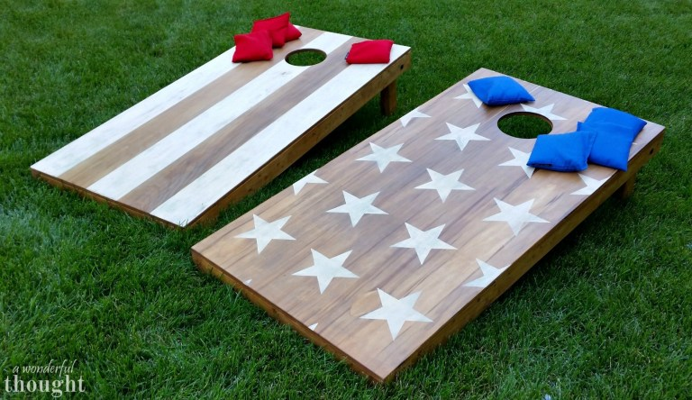

Date: Sunday July 27th

Ogdensburg Moose Lodge #814

$20.00 Team Entry Fee

Team Name: _________________________________________________

**Team Roster: Must be 2 person Teams**

Name **Signature

1)__________________________________________________________

2)__________________________________________________________

**Signature is required due to Liability & Injury. The Disclaimer for Participation on this event removes any responsibility of the Ogdensburg International Seaway Festival. Event Chairperson: Chris Cole

Return Entries: Entry Fee can be paid the Day of the Tournament

or

Enter Online using **Ogdensburg International Seaway Festival.org**